How to save the GPS data files to CSV Format

There is two ways to save the GPS data files to CSV Format.
First: save the GPS data files to CSV Format via Web Client.
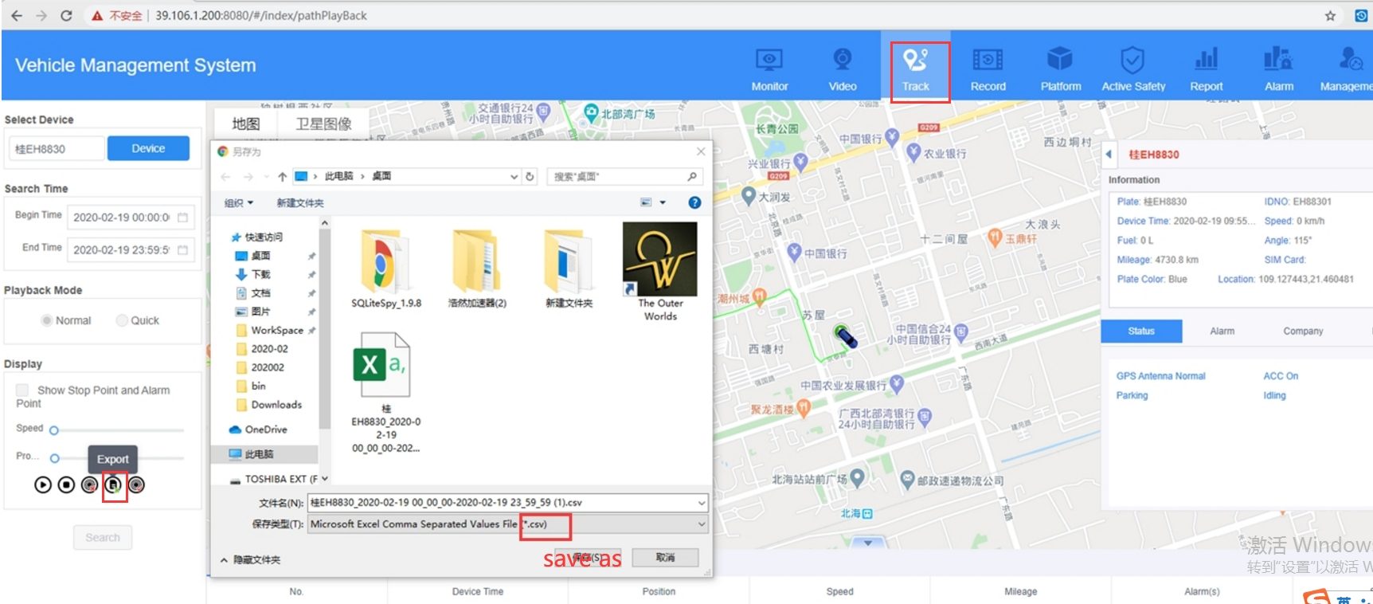

Second: Exchange the GPS data files from dat to CSV Format via tool.
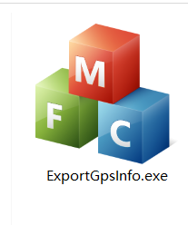
Kindly download it.
This the the default path of GPS data.
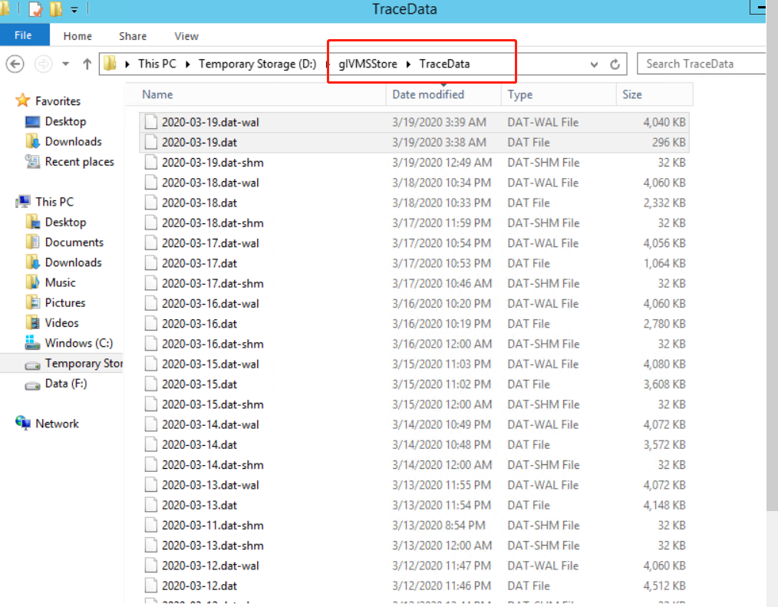
You should select your own path of GPS data. Kindly choose the Save path as below.

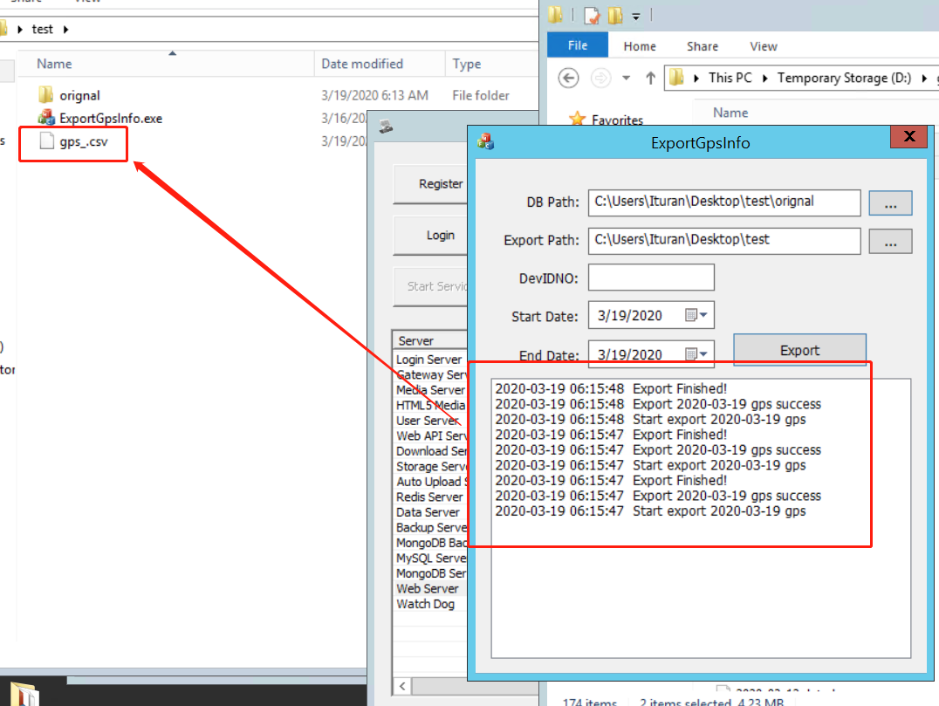
After all the steps. You would get the CSV Format of GPS data files.

