# How to test SDK about Face recognition

About testing SDK about Face recognition:

First. Update face recognition image.

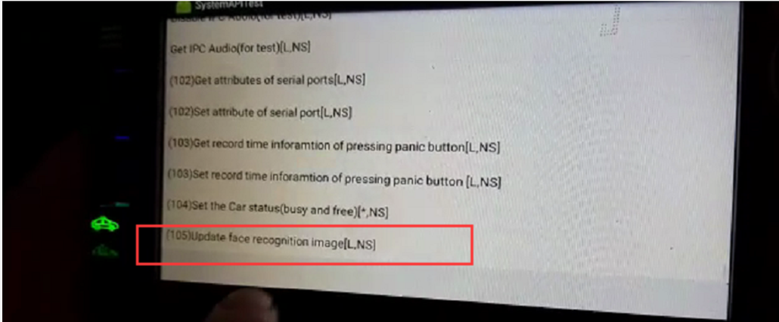

Second. Select the picture.

              Note： 1) Pictures name should be xxxx.bmp.

                           2)Pictures resolution should be 344*440 or 172*220

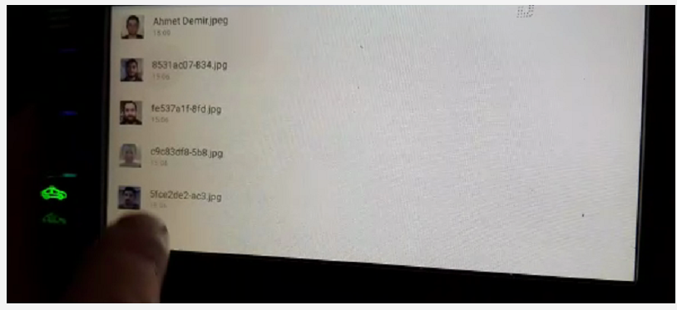

Third. Enable face recognition.

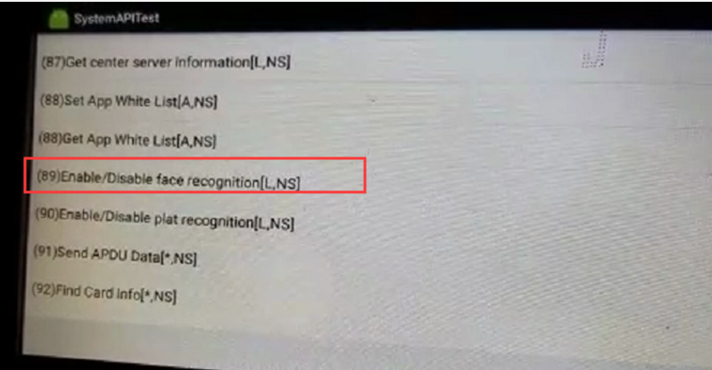

It will return picture name if the recognition is successful.

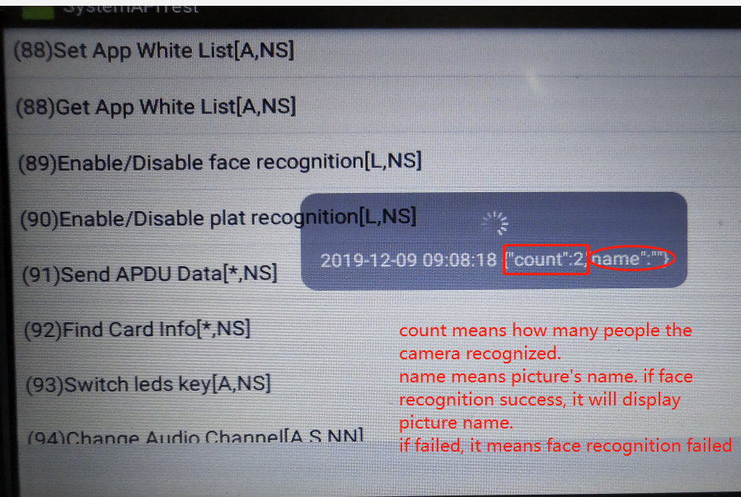

​

There are two ways to check face recognition failed:

1. Check if the human face is accurately aligned with the camera via video file.
2. Look at the recognition level of Hisilicon log, it will be successfully identified above 0.6.

