How to upgrade the tomcat version
- Back up the original Tomcat to D or E disk.
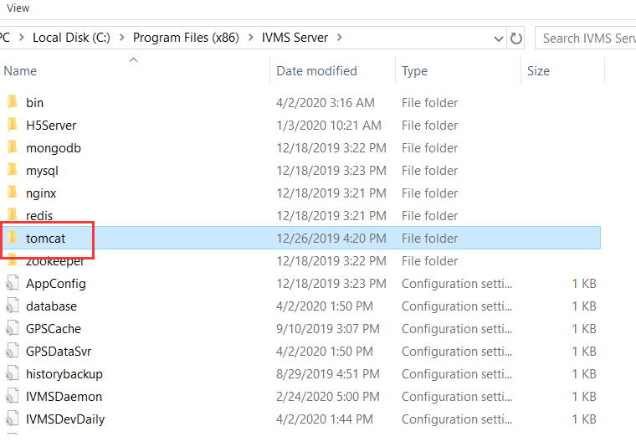
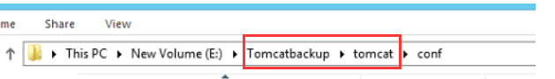
2. Replace the original tomcat with the latest one we provided.
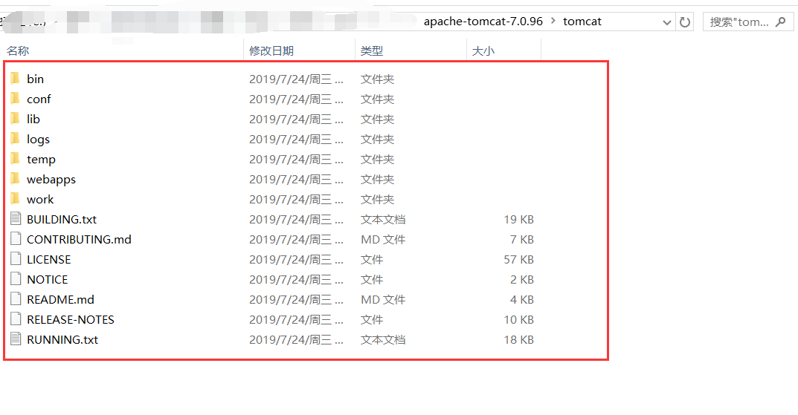
3.Please put your own original “ gpsweb” folder to the tomcat we using now.
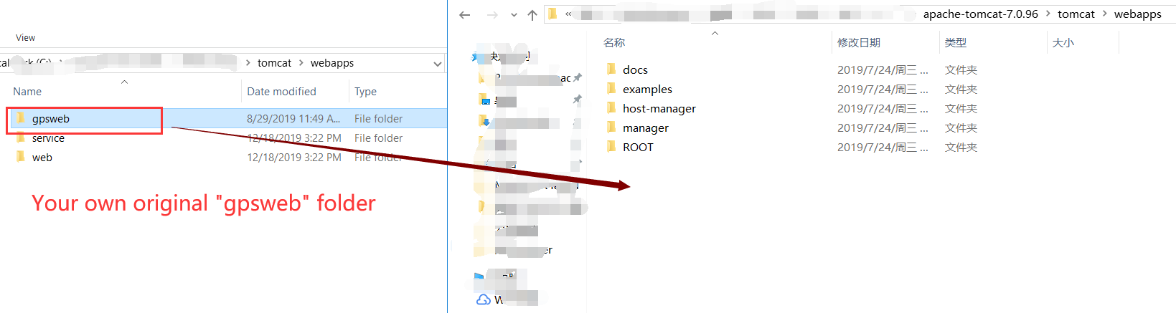
- Please use the same web port as before.
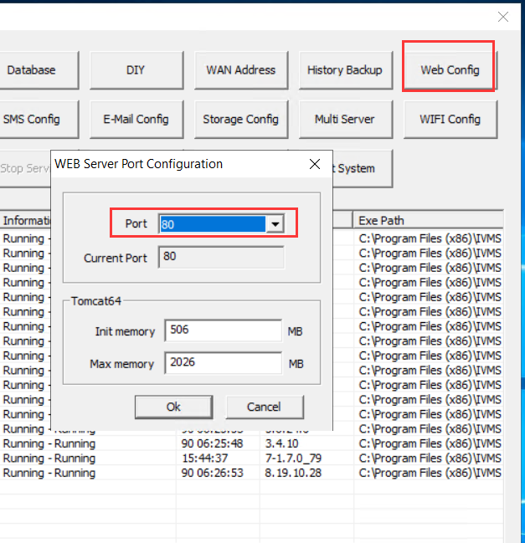
- If your web Server running failed as below.
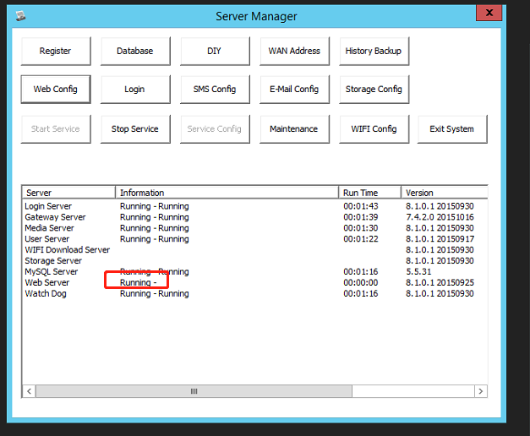

- Keep the ports as the your original files.
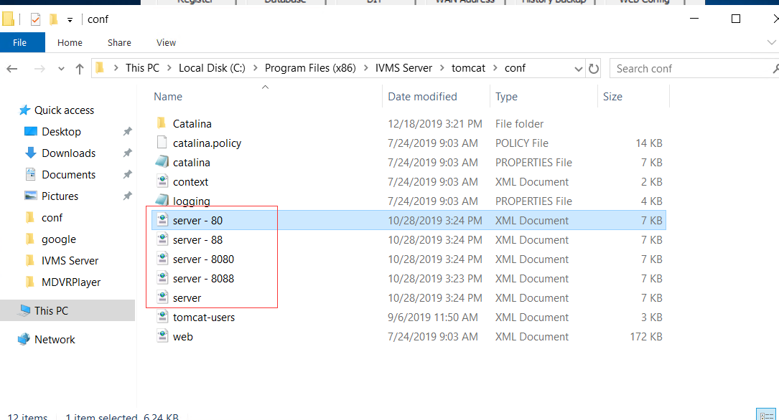
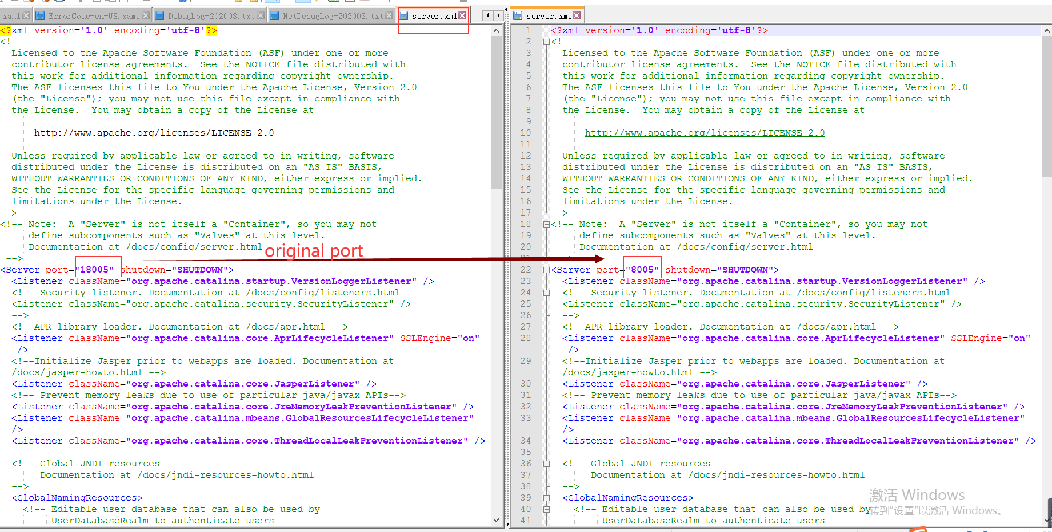
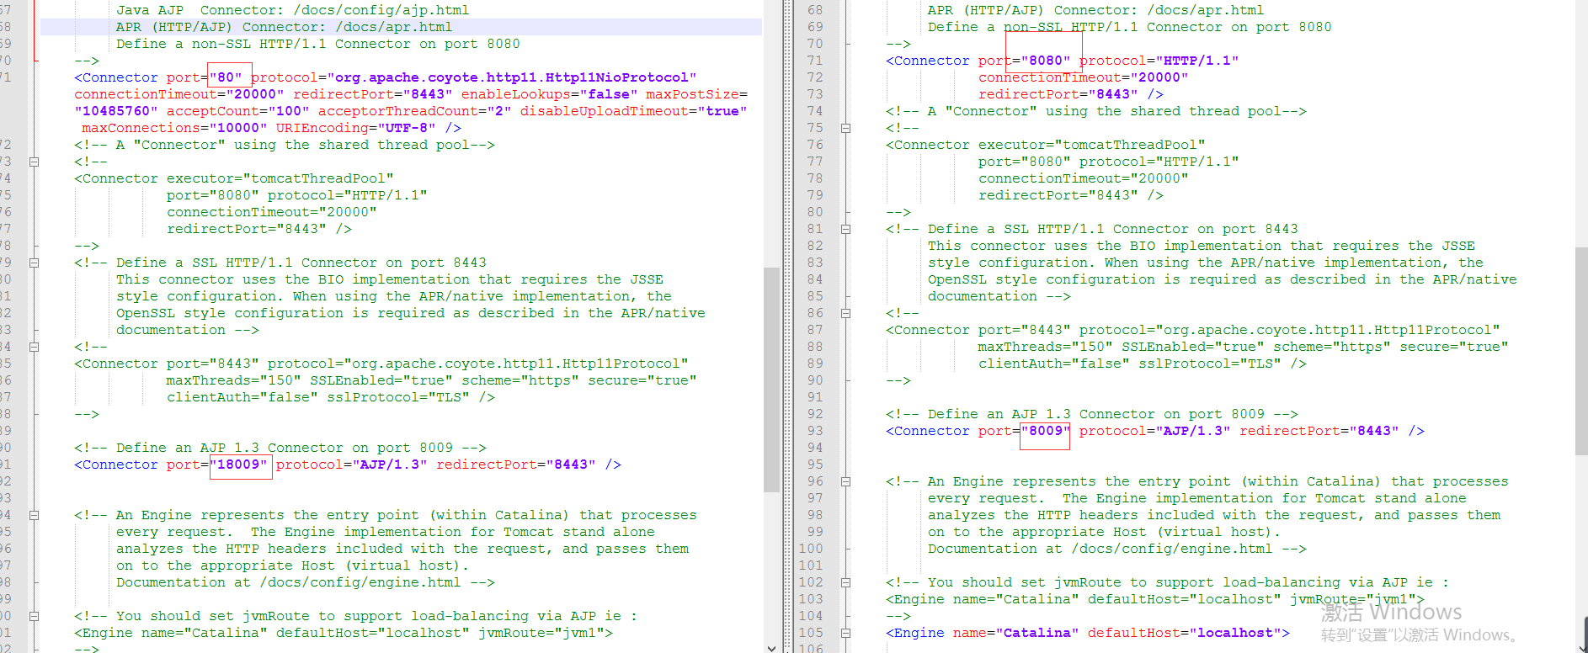

7. After all steps finished, your tomcat version have upgrade to 7.0.6.

