# How to set the account validity & license and role

1. **Account Description:**
2. Admin account: It is the highest privileged account, no role management, can set how many licenses for the level 1 account.
3. Level 1 account: Created by admin account, have role management.
4. Level 2 account: Created by level 1 account, have role management.
5. **How to set the user role and validity under level 1 account:**
6. Login the level 1 account, select 'Role Management' and add a new role.

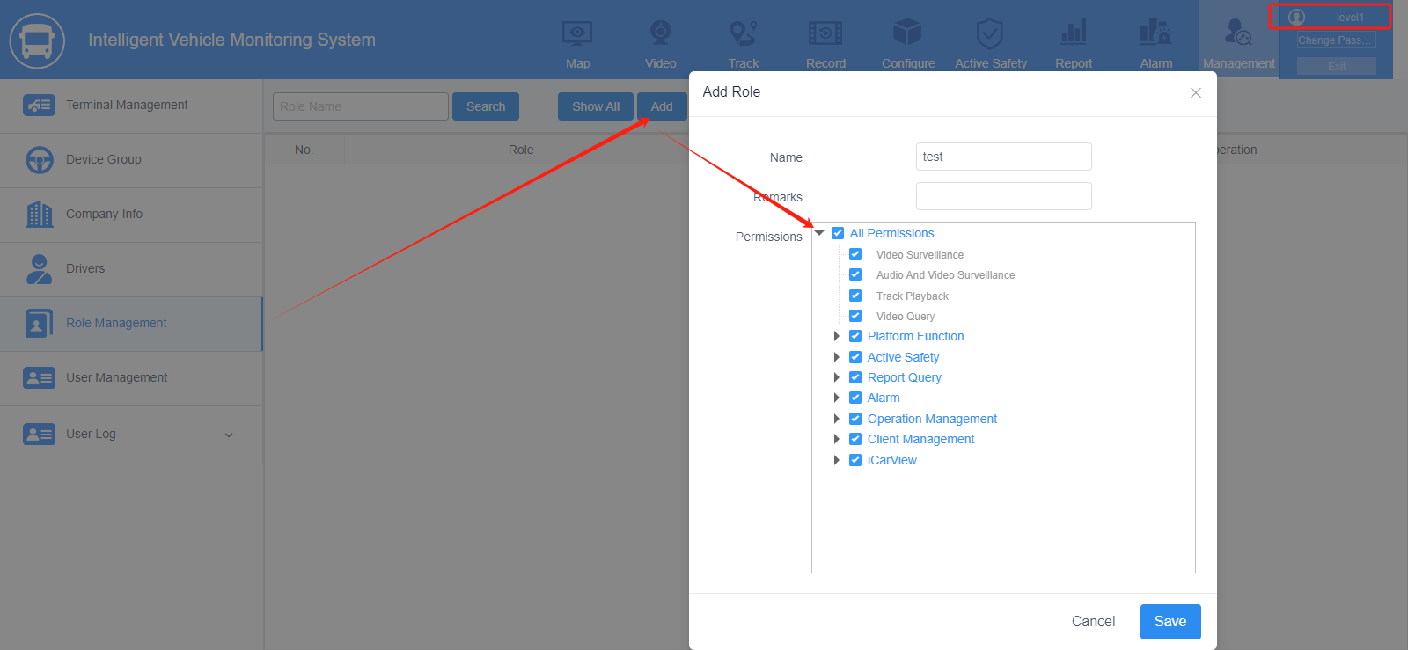

1. Select 'User Management' to add the level 2 account, and you can select role and set the validity in the basic information.

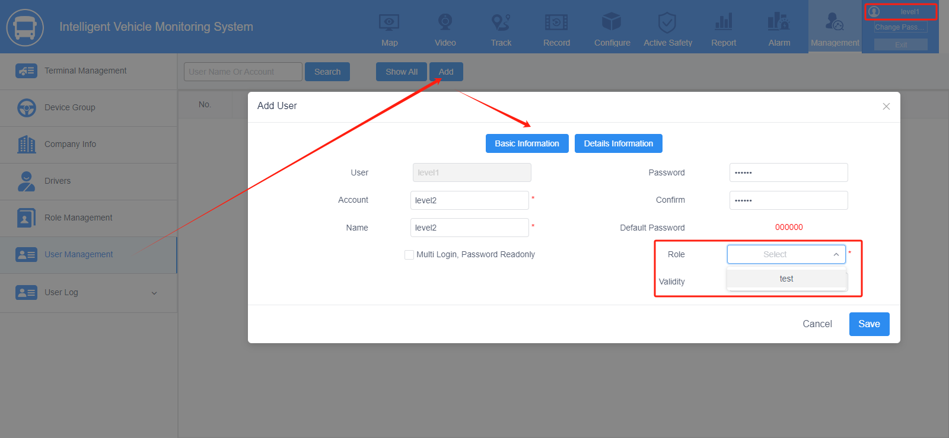

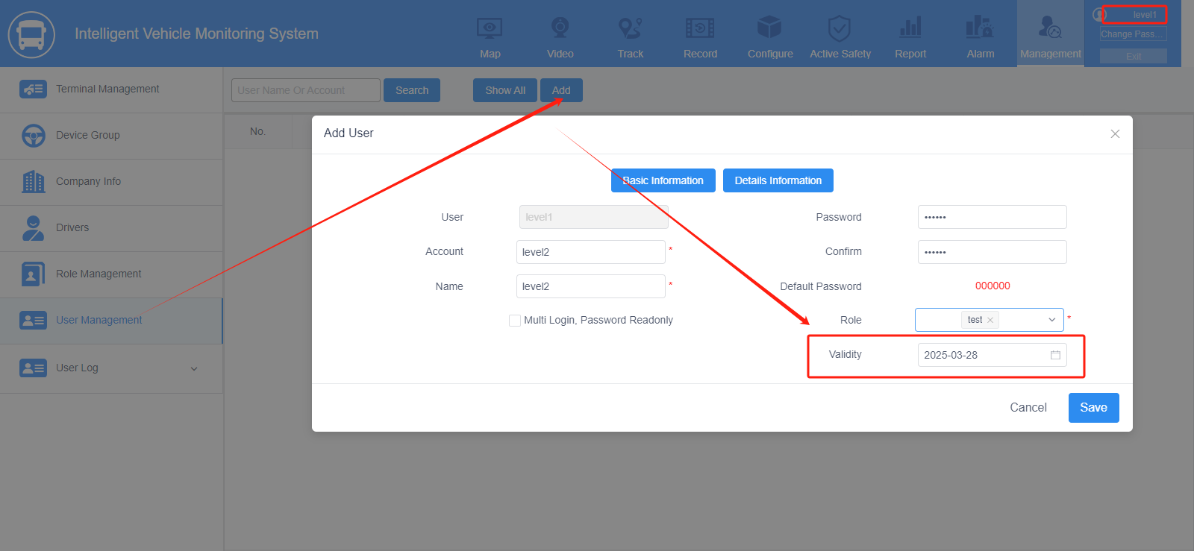

1. **How to set the validity and license number under admin account:**

Login the admin account, select 'User Management', click 'Add' to add a new account, then you can set the validity and license number in the basic information.

