## How to connect the Audible and Visual alarm

1. Find the audible and visual alarm and the 24pin cable, connect it as below:

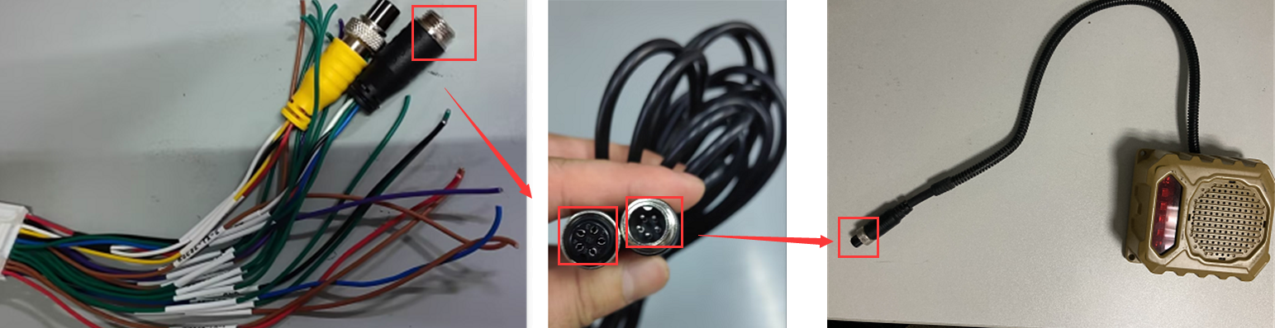

Audible and visual alarm connector definition:

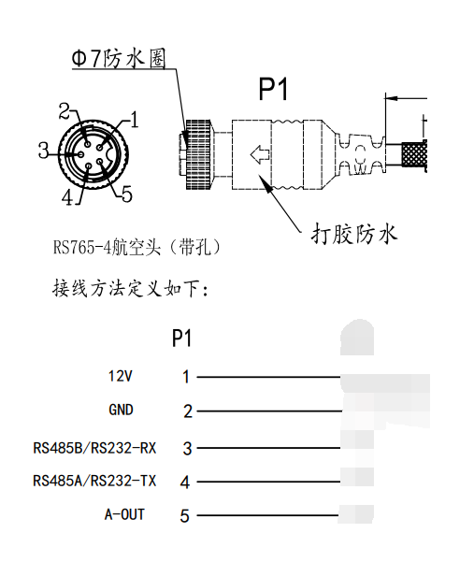

6m extension cable definition：

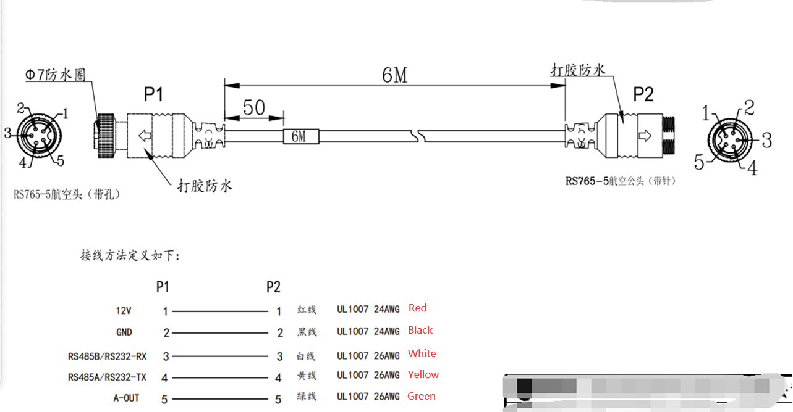

2. Connect the 24pin cable to MDVR side, power on the MDVR, and set the audible and visual alarm parameters.

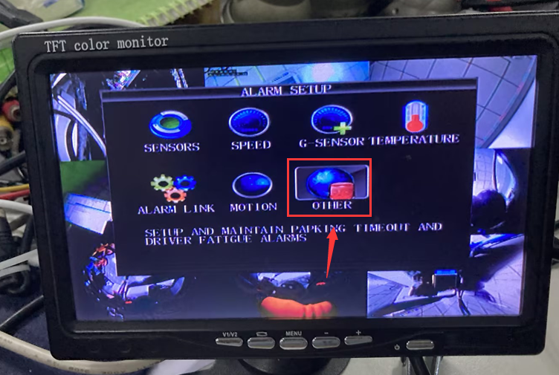

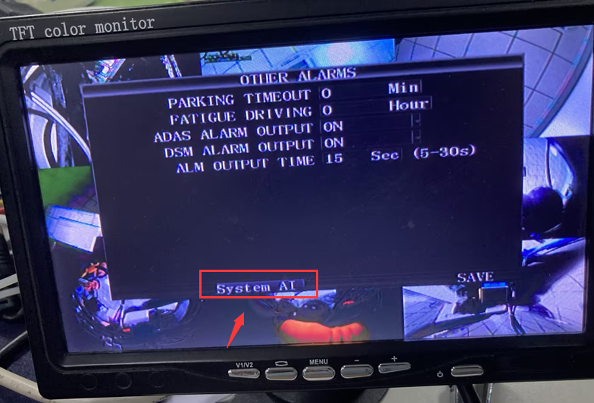 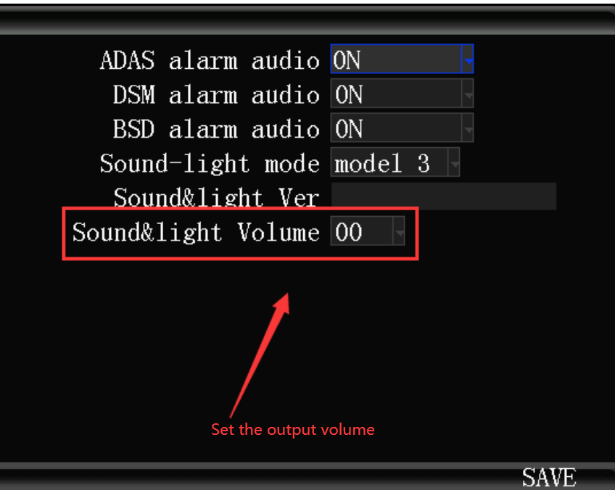

3. After this, when you trigger the BSD alarm, it will output sound and light on audible and visual alarm.