## How to remotely authorize AI algorithms

1. Power on the MDVR, check the **System info--System AI** page, make sure the firmware and AI model version matched.

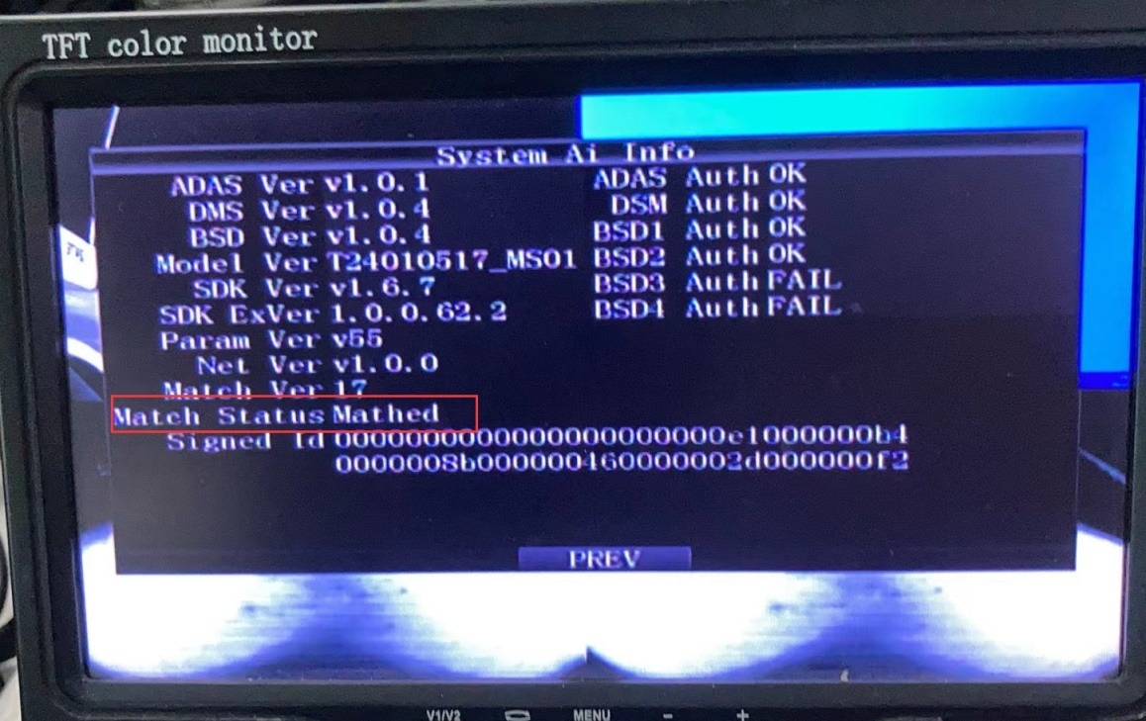

2. Use the SIM card to make the MDVR online, then send us the 4G module's IMEI.

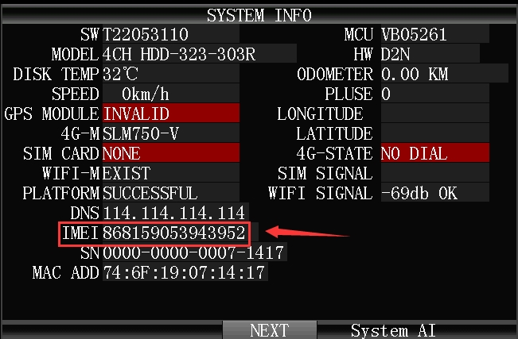

3. When we get the IMEI from our platform, we will issue authorization commands remotely via IMEI.

4. Customer make the MDVR online again via 4G, then it will automatically get the authorization information issued remotely.

5. MDVR will restart after it got the ADAS/DSM/HOD algorithm, and you can open the System AI info to check the algorithm again.