RFID Card Reader—RS232

# How to wire

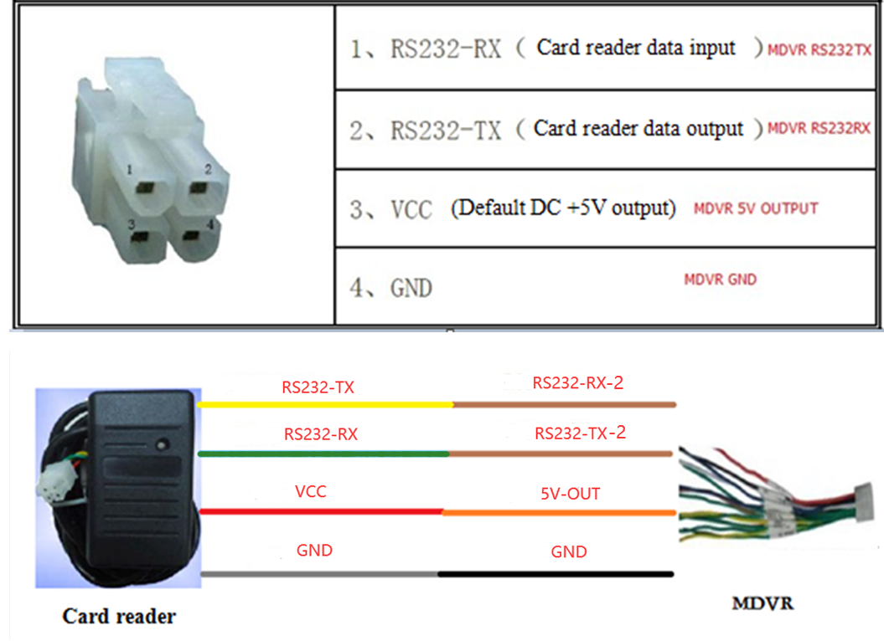

# Set MDVR

Log in MDVR and then follow the guide to open LRD IC function.

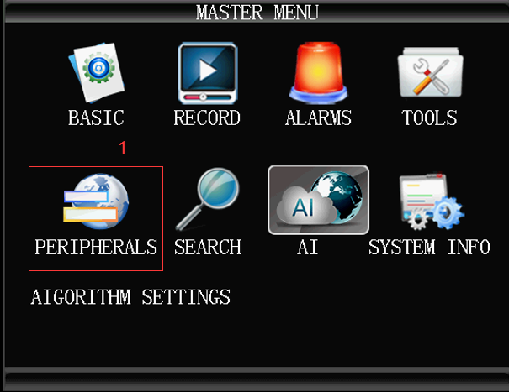

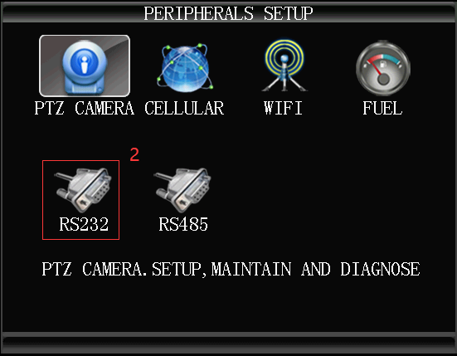

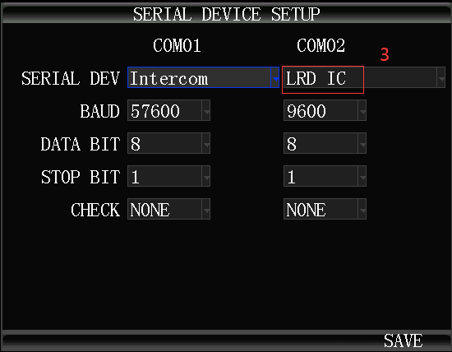

# Query at Client

* Log in IVMS client, then when you swiping the card, we can see the information in client.

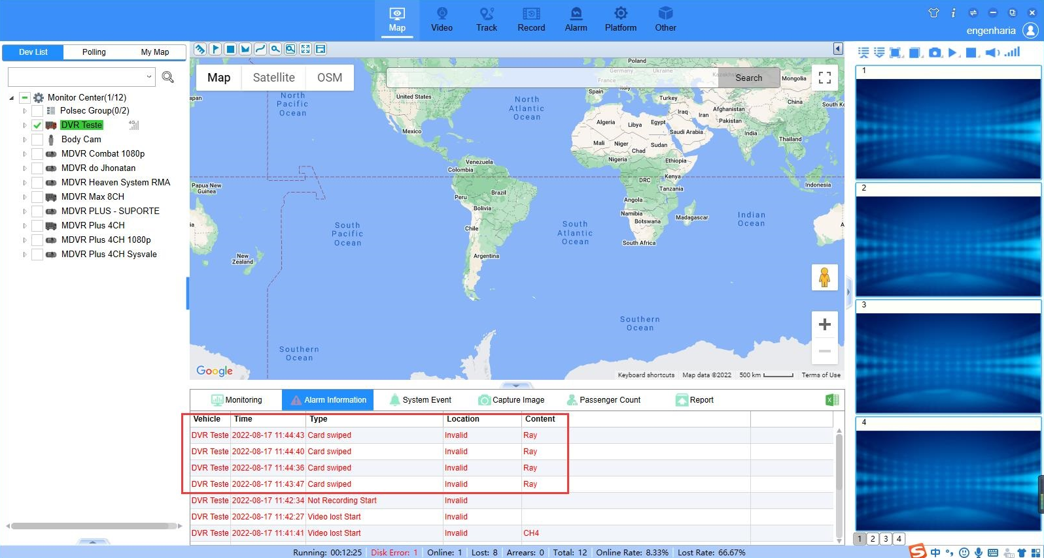

* Login the web, then we can check the report there.

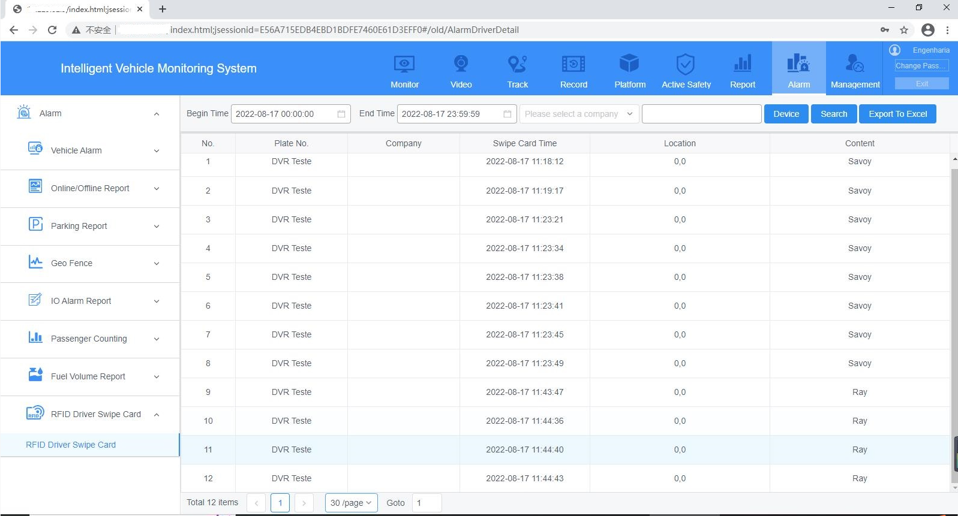

# NOTE:

This kind of swiping card can use for driver and student.

When they swiping card, there is an information send to IVMS.