1. Install the  Command Line Tool “SecureCRT”，to run the SecureCRTPortable.exe：

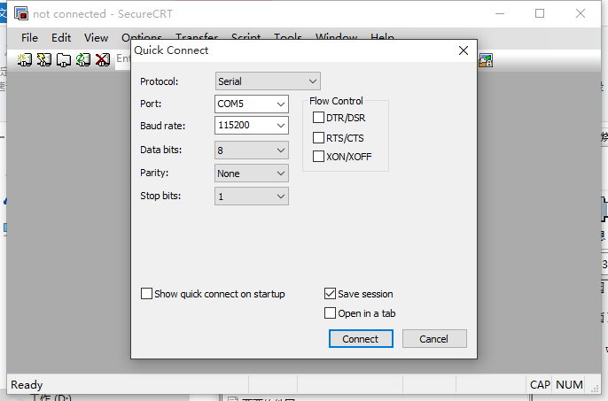

1. Connect the 3PIN serial cable to MDVR side, USB side connect to PC side.

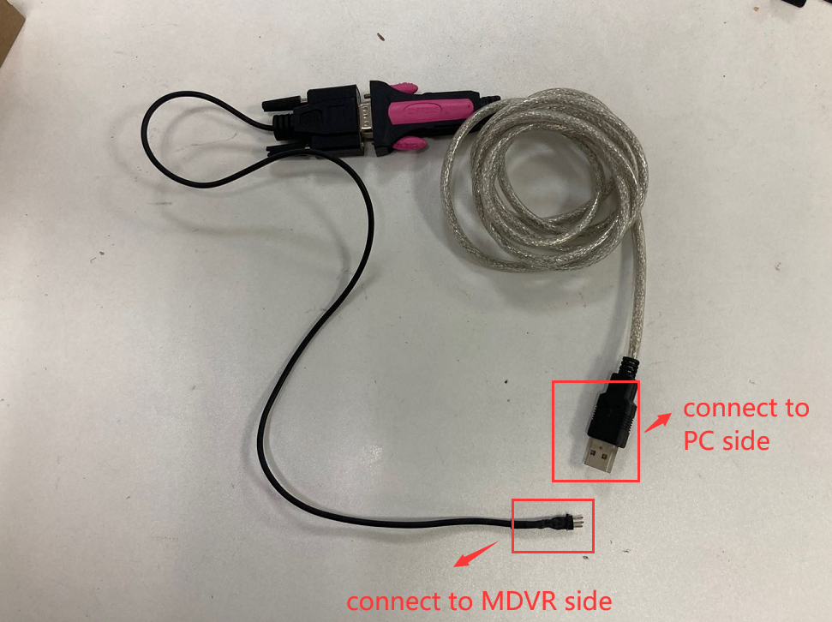

1. Port option：[[computer](javascript:void(0);) [management](javascript:void(0);)] – [[device](javascript:void(0);) [manager](javascript:void(0);)] , you will see the port [COM & LPT]

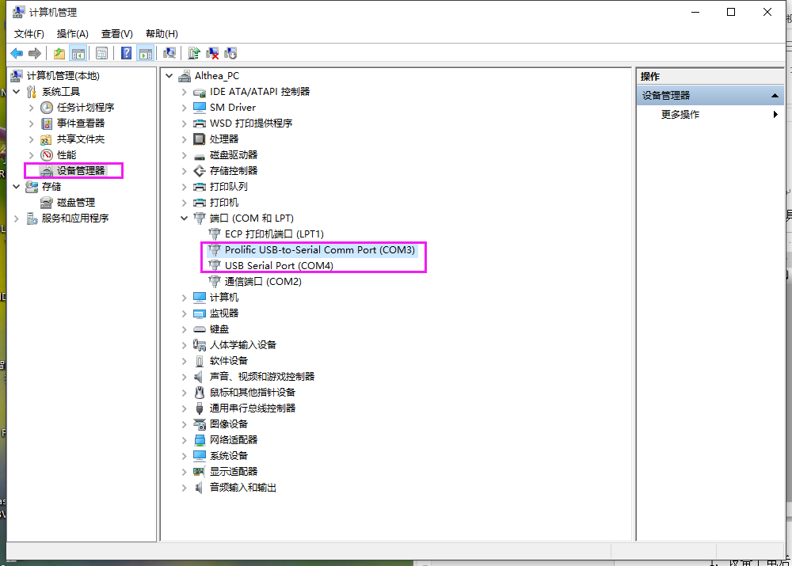

1. If it is working, it will show like this, then you can follow these step to save the log.

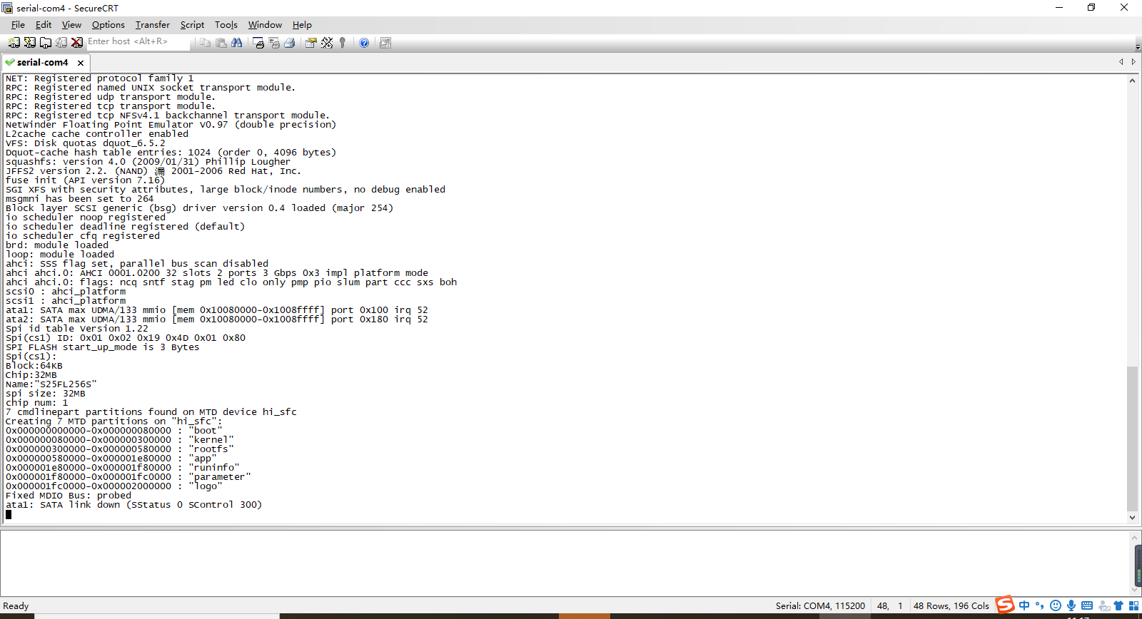

Log setting:

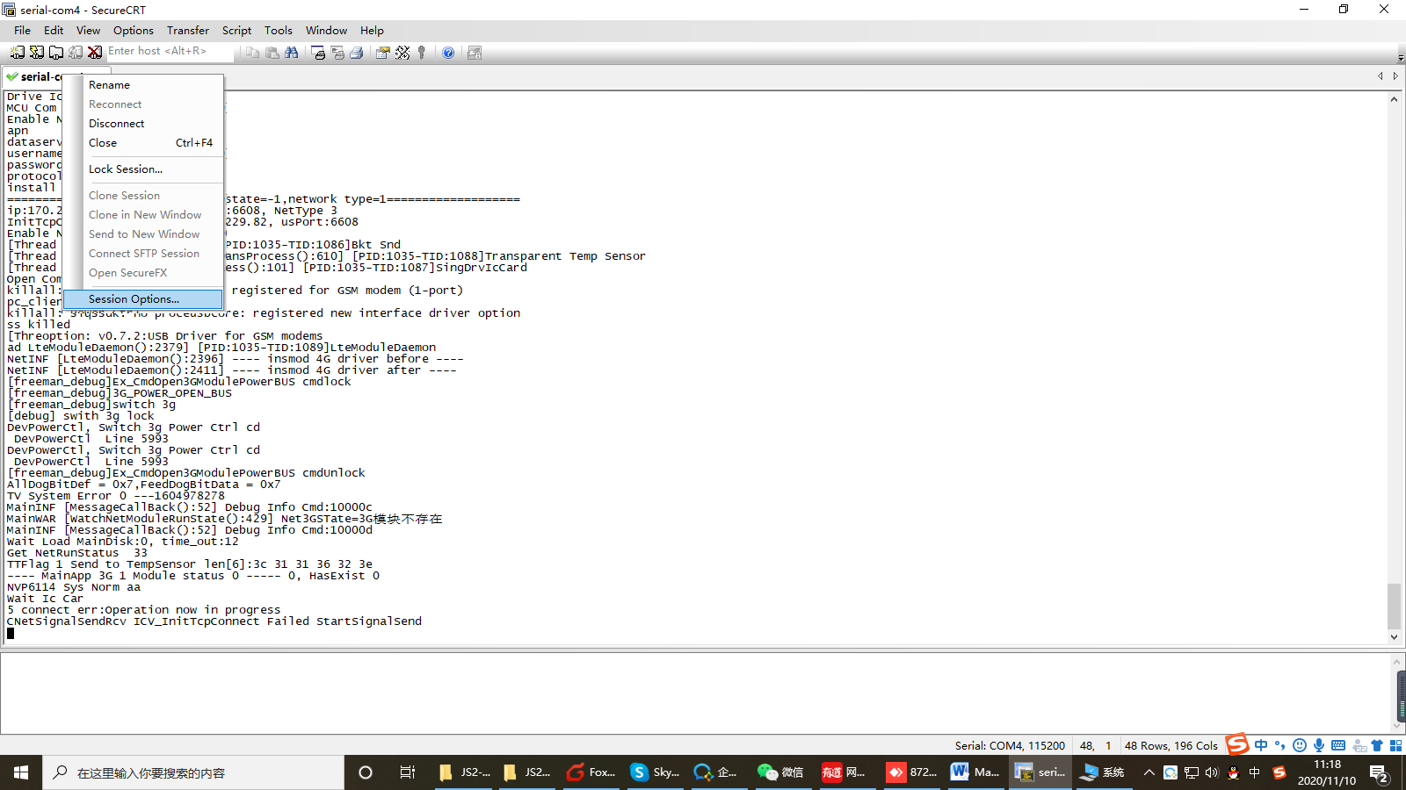

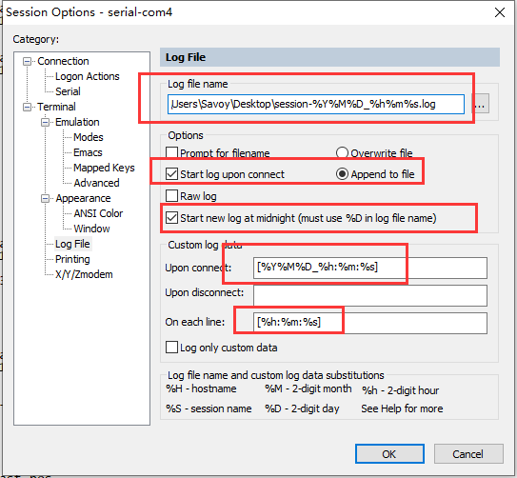

C:\Users\Savoy\Desktop\session-%Y%M%D_%h%m%s.log

[%Y%M%D_%h:%m:%s]

[%h:%m:%s]