**How to add Google Map API for the New version IVMS Server**

Due to upgrades in the new version server, the location of the Google Map API Key has changed. (NOTE: November 2023 and later versions)

1. Use Note book Open file ‘key.js’.

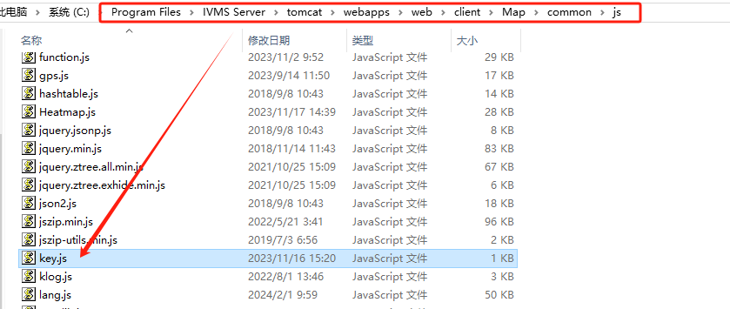

1. Fill in your Google Map API here.

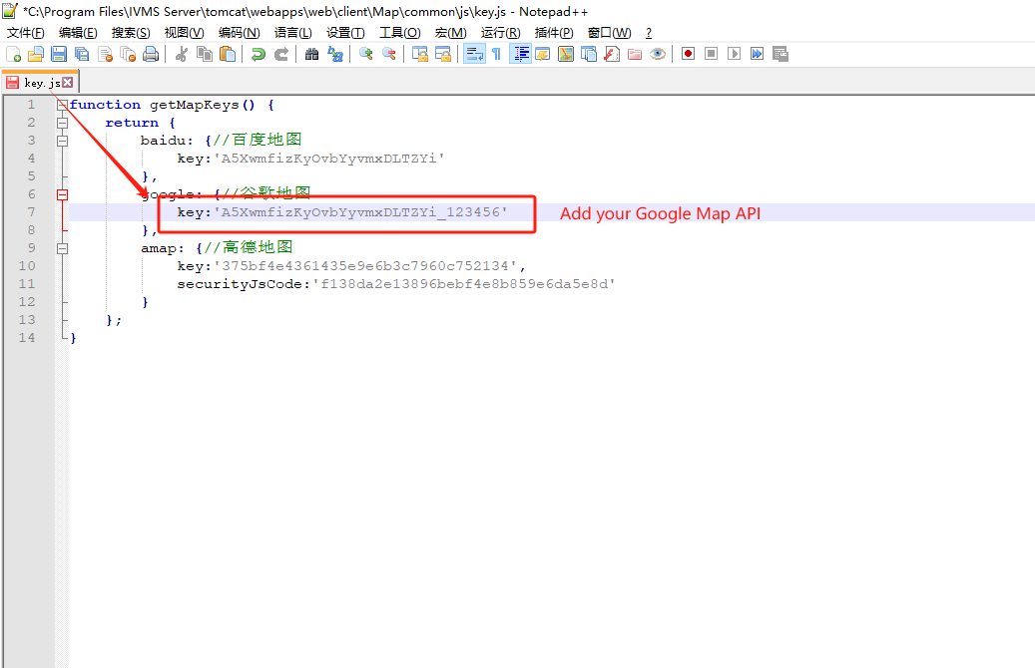

3. Restart the web server.

